Solution Architecture - Technology

Canopius Enterprise Data Management – Data Strategy

Document History
Version No. | Date | Author | Revision Description
0.5 | 15th October 2021 | Christian Bracchi | Additions to document and feedback
0.6 | 19th October 2021 | Christian Bracchi | Additions to document and feedback
0.7 | 21st October 2021 | Christian Bracchi | Additions to document and feedback
1.0 | 22nd October 2021 | Christian Bracchi | First Release

Referenced Documents
Document Name | Document Description | Document Location
Canopius Requirements | Functional and non-functional Requirements that are specified for the data platform | https://canopius0.sharepoint.com/sites/DataStrategy2/Shared%20Documents/General/3.%20Business%20Requirements
Canopius Azure Landing Zone – High Level Design | Provides high-level overview around the infrastructure components that host and support the Azure Landing Zone
Data Architecture | Data Architecture detailing the movement and storage of data across the platform | https://canopius0.sharepoint.com/sites/DataStrategy2/Shared%20Documents/General/8.%20Data%20Architecture
Cloud Infrastructure | Cloud infrastructure component detail | https://canopius0.sharepoint.com/sites/DataStrategy2/Shared%20Documents/General/12.%20Cloud%20Infrastructure

Contents
Solution Architecture - Technology i
Document History i
Referenced Documents i
1. Solution Overview 3
1.1 Future Architecture 7
1.2 As-Is Architecture 8
1.3 Transition Architecture 8
2. Architecture Goals and Constraints 10
2.1 Architectural Assumptions and Decisions 10
2.2 Solution Architecture Attributes 10
2.2.1 Common Services 11
5.1.1 Common Components 11
5.1.2 Portability 11
5.1.3 Capacity 11
5.1.4 Performance 12
5.1.5 Availability and Reliability 13
5.1.6 Scalability 14
5.1.7 Securability 14
5.1.8 Usability 15
5.1.9 Regulatory 17
5.1.10 System Management, Monitoring, and Administration 18
5.1.11 BCP/DR 19
5.1.12 Other Solution Architecture Attributes 19
3. Application Architecture 20
3.1 Logical Architecture 20
3.1.1 Logical Application Component Characteristics 26
3.1.2 Logical Application Component Interactions 27
3.2 Physical System Architecture 31
4. Security Architecture 43
4.1 Security Solution Overview 43
4.2 Security Architecture Goals and Constraints 45

Solution Overview
A Data Strategy programme has been initiated to rationalise the data estate and deliver new data capabilities to help Canopius achieve its strategic imperatives, whilst providing a robust data foundation for organic growth and onboarding of new acquisitions. A single portal for data and analytics containing consistent, conformed low-grain information will remove manual, repetitive data processes enabling business users to spend time on analysis and data-driven decision making across all Canopius Group entities.
The following diagram represents a technology view of the solution architecture and illustrates the various interactions that can happen between components. It is designed to be flexible in its usage as the components are capable of carrying out multiple functions in some cases, but each will have primary purpose and usage.
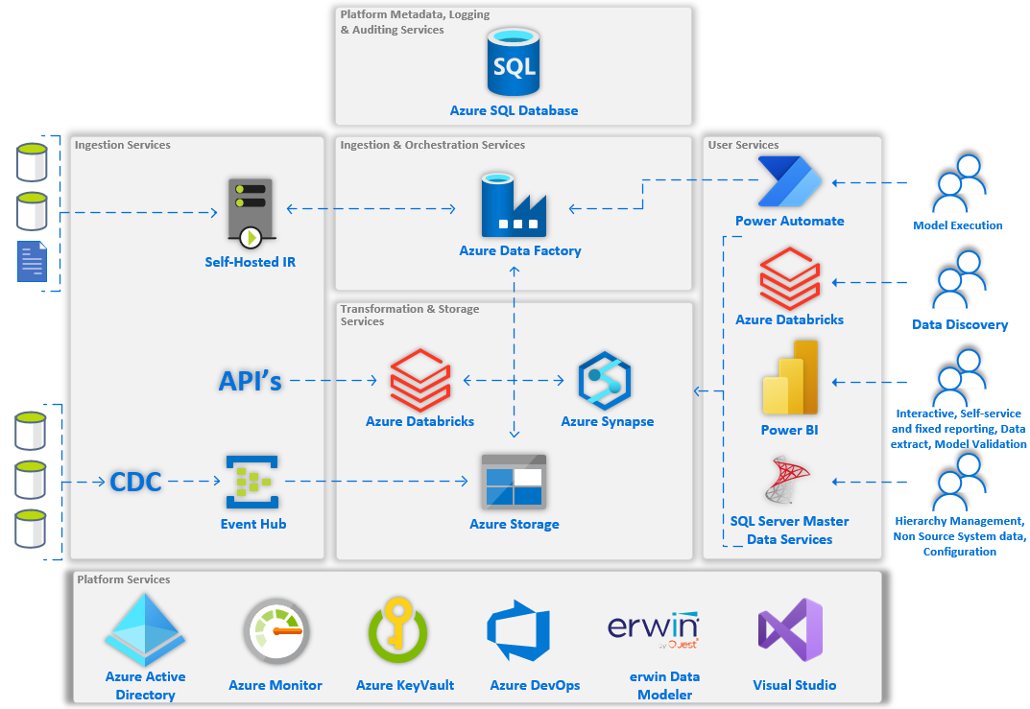
Figure 1.1 - Solution Architecture - Physical View
The above diagram represents the major technology components that will comprise of the target solution architecture. The solution is to manage the ingestion, processing and preparation of data from various source systems across the Canopius estate. It brings together the data to be used for reporting, but also to act as a processor for the delivery or availability of data to a limited number of other systems. The solution is capable of a variety or reporting capabilities ranging from fully interactive reports, through to query data discovery and data science.
It is designed to be built from components that are relevant in the market, commonly used and offer a level of scalability to meet Canopius’ foreseeable data requirements.
These components are split into another of areas such as:
- Platform services – These will be used or will make use of the other platform components to provide such attributes such as security, monitoring and dev ops.
- Integration services – Used for the access to source data for the data platform
- Integration & orchestration services – Provides orchestration of activity within the data platform, which will commonly be for the purposes of the extraction, transformation and loading of data, but also the enable orchestration of other process on the data platform that may be initiated by end users. Additionally, components here will be capable of extracting data from source systems / files.
- Platform metadata, logging, and auditing services – Any metadata that is used by other components in the architecture will be sourced from here and it will provide a common place for components to log as required and will also serve as a common place to understand what is happening across the architecture as jobs as in progress and what has happened for completed jobs.
- Transformation & Storage services – These components are really the core of the data platform and provide the capability to store, transform and query data.
- User services – These provide various access mechanism for management of data, reporting and process control.

These components will be further detailed in section 3 of this document.

The following diagram gives a view of some components together with a view of the high-level data architecture.
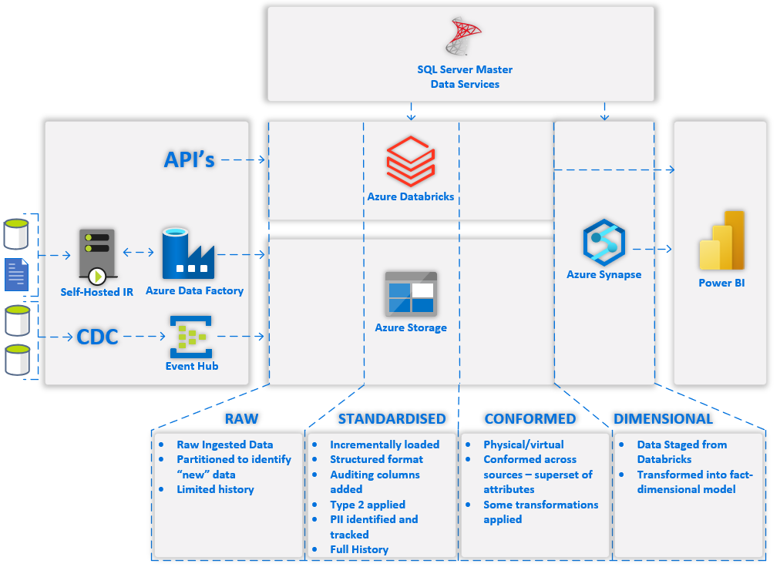
The above diagram represents the majority use case of data flowing through the platform. To explain this, we will break down into several areas, describing their purpose and what they do.
Data Sourcing
- API’s – These are any API’s that need to be accessed by the platform to retrieve data into structured/semi-structured format. For this purpose, Azure Databricks will be used to source this as it is well positioned to access API’s and process the results in the variety of libraries available to python and PySpark capabilities.
- Azure Data Factory will make use of it’s integration runtime to access on-premises data sources such as databases and file stores. It has capability to get data from a variety of databases and pull that data into the Azure Cloud Platform and store in Azure Storage. The same applies for any files retrieved.
- A Change Data Capture (CDC) tool will be used to monitor database logs, identify transactions within those logs and send the records in the form of inserts, updates, deletes, and full tables refreshes where necessary to the cloud platform. These messages will be received into Azure Event Hub, which will then periodically store the messages to Azure Storage for further processing.

Data Processing & Storage
- Azure Databricks runs on the Apache Spark platform and has extensive capabilities of processing data using python, libraries (with boxed functionality) and PySpark. With these languages it is possible to perform extensive manipulation of data to move from an unstructured / semi-structured format to a structured one. This processing will take place through code in notebooks where these notebooks will be generic metadata driven and instantiated notebooks with transformations fully coded. An added advantage of Databricks is making use of its Delta format tables, which offer ACID transactions. This allows us to treat data in a very similar way to relational database tables, and through spark SQL language make these tables familiar to query.
- Azure Storage will be used for storage of data across the platform. It will be used to store data retrieved from API’s, from Azure data factory, from Event Hub, and will be the primary storage area for any data processed within databricks. Other technologies such as Synapse also use Azure Storage, but this is abstracted within synapse. Each of the “zones” above will be in a separate Azure Storage account that will be mounted to databricks so that it can access the files as required.
- Synapse has a “dedicated pool” that is a cluster based MPP relational database. It is designed for processing large volumes of data with efficiency and is aimed at data warehouse data models, and this is where the dimensional model will be housed.

Data Structure
- Raw is used for the ingest data into the platform and will also be used as the source for identification of changes.
- Standardised holds the full data history for each table from source as type 2 changes. It will also be the start of tracking PII. This data will be fully processed through azure databricks and stored in Azure Storage.
- Conformed will store the conformed modelled data across data source with required transformations and will allow for physical (tables) or virtual (view) storage. This data will be fully processed through azure databricks and stored in Azure Storage.
- Dimensional will be processed and held within Synapse dedicated pool and will be in the form of dimension and fact star schema structure. This will be the optimal structure for end user reporting. Transformations in stored procedures will take the data from the conformed shape to the fact dimension structure.

Presentation
- Power BI will be used for end user reporting through dashboards, reports, and paginated reports. It is anticipated the model within Power BI will hold all the data required for interactive and self-service reporting.

Orchestration & Scheduling
- Azure Data Factory will not only be used for ingesting and store data from databases (that are not available for CDC) and files, but also for the orchestration and scheduling of tasks across the platform. It will use metadata from the platforms Azure SQL Database to execute tasks in parallel and to achieve loading through the platform.

Future Architecture
The above view of the architecture illustrates a starting position and doesn’t include items such as an enterprise service bus (ESB) that may be required in a future version. The purpose of the ESB is to provide mechanisms for:
- Applications to get data from another application
- Applications to push data to another application
- Processes to be coordinated across applications
To be explicit, applications here may be a COTS product that is being used within Canopius, a custom developed application that is being used within Canopius, and also the new Azure data platform that the majority of this document discusses.
The following diagram illustrates two versions of an enterprise service bus implementation at a high level. It is illustrative only in the way of providing two alternative example technology solutions. Although this isn’t a current requirement, it is a future one, however the addition of an API layer / Enterprise Service Bus at a later time, and the exclusion of this in the first version of the architecture is not expected to limit the ability of the overall data platform to act in this role in the future.
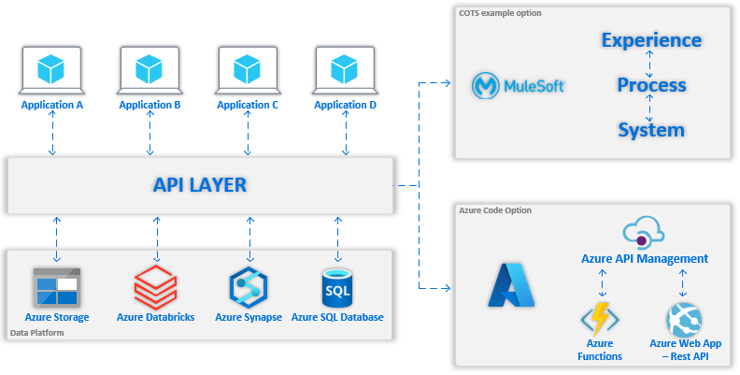
Figure 1.2 - Example Enterprise Service Bus technology implementations

Transition Architecture
There will be the first version of the architecture to be deployed for claims and underwriting and as transition architecture between the current and the target architectures where two components will be added in the target architecture in a change data capture tool for capturing and transmission of database changes, along with Power Automate to enable end user data platform process initiation.
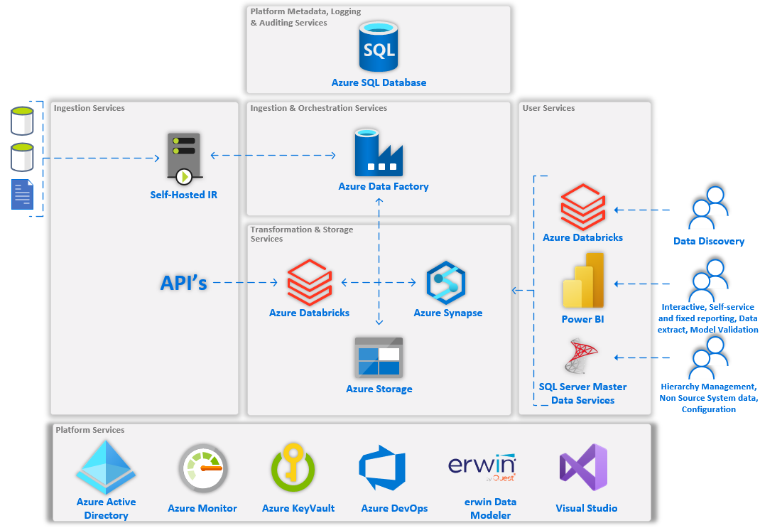
Firstly, is change data capture, where a tool selection is currently in progress. Once the tool is selected there will be a revised low-level design with the support from the vendor. This will most likely require additional on-premises compute to be provisioned as well as working with the various source database owners for any installation and access configuration to the databases. Additionally, the Event Hub target with connectivity will be configured as well as the data capture settings to store the output into Azure Storage. The change data capture tool can be put into operation to load required tables from source into event hub. Depending on the status of what data has already been source through implementation into the platform there would be a transition development and cut over to make use of the change data that is being received for that source.
Secondly, is Power Automate which is the target technology for end users triggering processes within the platform. This is anticipated to be used by finance and actuarial teams and therefore is not necessary for the first version of the architecture. Once the requirements have been fully explored, the appropriate Azure data factory pipelines and Power Automate App can be designed and implemented.

Architecture Goals and Constraints
The Architecture goals and constraints section provides a description of goals and constraints of the Solution Architecture. The following subsections each provide specific architecture goals and constraints.

Architectural Assumptions and Decisions
Below are some concise representations of the application and technology principles as outlined in section 4 of the “Vision Document”.
From a technology perspective, the first major constraint was that the technology should be held within the Microsoft Azure cloud platform. This was provided as a requirement during the RFP process to initiate the programme with services company.
Following on from this constraint, direction was preferred to use Microsoft components that are native to the platform above third party. This was driven by the current on-premises implementation of the platform to be predominantly Microsoft focused and therefore skills of the team also being Microsoft BI focused. See section 2.2.2 for the common components that are also a constraint for usage in the data platform.
Control over technological diversity should be considered to minimize the non-trivial cost of maintaining expertise in and connectivity between multiple processing environments. The technology chosen should also be considerate of market trends and current skills within the market so that further development and support of the platform should be possible.
The architecture should be capable of supporting current and expected future demands of Canopius reporting and therefore required data loading and processing requirements. This alone forms a major part in the decision to adopt a cloud-based platform.
Modularity / Portability should be considered for architectural components where each component should carry out its desired purpose, and it should be considered that a technology component can change to an alternative that has similar capabilities, fits with the requirements of the solution and does not cause the solution to be overly impacted.

Solution Architecture Attributes
This section of the document will draw out some of the high-level attributes that the architecture needs to illicit. The complete list of requirements can be seen in the “Canopius Requirements” excel document.

Common Services
There are certain services that will be used by the platform that are described in the “Canopius Azure Landing Zone – High Level Design” such as:
- Azure Active directory – There is an azure active directory services that is in place within the Canopius infrastructure that has account syncing with the on-premises active directory and therefore Canopius user logins should be authenticated and authorised against this service.
- Azure Monitor - Will be configured to monitor the health of network resources such as virtual networks, NSGs, route tables, NICs, and public IP addresses
- Power BI – This has been selected by Canopius as the reporting tool of choice and there is already infrastructure and governance in place.

Common Components
Currently no common components are required/specified.

Portability
Although there is no specific requirement, consideration should be taken when selecting technology so that there is either a possibly to directly port to a similar technology or an alternative cloud platform, or porting with some development/change required.
There will be certain functions within the platform that will not be portable without significant rework, for example reports that are built within a proprietary technology.

Capacity
It is anticipated that the total storage of a view of the data to be incorporated into the platform will be approximately 2 terabytes in volume and will grow at approximately 10% per year. This estimate for storage capacity is based on the total volume of sources system as defined in “Source System Scope V1.1” document, but also with an added margin for contingency.
The solution should not however be restricted to a level of storage, and should offer a service where additional storage can be easily added / configured across components.
Memory and processing capacity across the platform should be sufficient to meet the demands of processing and querying the data. As the exact processor and memory requirements are unlikely to be known prior to implementation, the cloud technology components should be able to be configurable as to meet the required demand.
There may be technology components in the platform that may need to have a service level change to accommodate capacity requirements in the case of changes to requirements such as processing timeliness, complexity and volume of transformation operations, volume of data, breadth of data, number of users (queries).

Performance
Although the performance requirements are document in the requirements document, they will be consolidated and mentioned here also for simplicity.
Data Refresh
Data refresh from operational and reference data are specified below, however this will be dependent on the ability to source the data from the source operational system in a timely manner that is allowed by that source, and if there is a requirement to do so.
Source | Source Sub-set | Minimum frequency | Desired frequency
Operational Sources | All in scope | Daily | Intra-day - 30 minutes*
Operational Sources | Subset (TBD) | Intra-day – 30 minutes* | Intra-day - 30 minutes*
Reference Data | All in scope | Daily | Intra-day - 30 minutes*
Reference Data | Subset (TBD) | Intra-day - 30 minutes* | Intra-day - 30 minutes*

* This is a desired frequency and will depend on the number of sources, volume of data and level of transformation required, as well as resource specification.
Processing Time
It is expected process time of processes to be completed in less than 2 hours excluding source system extraction.
Response Time
Below are the currently understood requirements for response times for user interactions with the system.
Scope | Required response time
Opening reporting portal | A few seconds – assumed 5 seconds *
Paginated report execution | < 10 seconds *
Dashboard/Interactive report execution | < 5 seconds *
Engine execution - Actuarial Reserving / Syndicate Accounting / FP&A model (adjustments, earnings, technical provisions) | < 30 minutes *
* At present, no reports or detailed engine specification has been completed and the data models to be used are in progress. Therefore, these execution times may need to be revised or they may be mitigated by a change in the capacity requirements of the reporting and database engine.
Regarding the paginated report execution, these reports may operate over “serverless” components in the architecture for cost efficiency reasons, and therefore if this exceeds the response time and it needs to be maintained then the data for the report may require further preparation.
Regarding the engine execution, this execution time would be expected to be maintained, however it should not be expected for multiple simultaneous executions of each engine.
Onboarding
The solution should be capable of onboarding new data into the platform “quickly” for systems that are like existing. For example, if there is a policy management system(s) that has already been loaded and modelled throughout, then it should be possible to onboard a new policy system into the platform and make available for reporting without having to perform the majority of transformation development. This requirement will in the majority be considered as part of the data architecture but aided by technology components where applicable.

Availability and Reliability
The system will need to be available during business hours, which is 8am Singapore to 6pm Pacific Time, under normal circumstances, however during month and quarter end processes the hours of availability extend to weekend hours where required.
It is expected that components be used within the architecture that allow for fault tolerance and are inherently reliable in so much as if a cluster is being used then it should perform in a highly available configuration and if a node within the cluster fails this should typically not affect what is happening on the platform. This is expected to take place within an Azure region and not across regions which will be discussed in disaster recovery.
In the event that a component in the region fail, and it is a SaaS / PaaS component then Azure will be responsible for the availability of that component and SLA’s for their availability should be considered. A summarised version of these SLA’s is documented in “Canopius Azure Landing Zone – High Level Design”.
In the event that a component that is contained within IaaS (e.g. software running on a virtual machine) then it will be expected that the team supporting the platform will attempt to understand and correct the problem.
In the case of platform code being identified as causing an issue, then the team supporting the platform will try to identify the source of the problem, triage and provide a resolution. This may require discussion that will be further detailed in a support agreement for the platform.
The primary Azure Region for the platform will be UK South, with a region pair of UK West, as described in “Canopius Azure Landing Zone – High Level Design”. Although, these are the chosen regions, it has been considered that alternative regions that could be considered would be North and West Europe regions, so from a legal view, it is accepted that the data may reside outside of the UK.

Scalability
The components within the architecture should be necessarily scalable through configuration and/or by design, so that anticipated future Canopius requirements such as processing timeliness, complexity and volume of transformation operations, volume of data, breadth of data, number of users (queries) can be maintained within the platform.
As part of meeting these demands it may be required that changes to the service-tier, performance level and/or number of nodes. Some of these changes would be considered to be configuration changes only and therefore seamless, however some changes may require redeployment or migration activity to take place.

Securability
It is required that all data stored within the platform is stored encrypted at rest using Azure managed keys and conform to NIST standards.
Azure storage is encrypted and decrypted with AES 256-bit encryption as standard and conformance and benchmarking for NIST standards can be found here for nist-sp-800-171-r2, nist-sp-800-53-rev-4 and nist-sp-800-53-rev-5.
If it is later required that storage is “double encrypted” then this is also a feature of Azure storage, however the impact of this should be considered before enabling.
It is required that connections be made using a minimum of TLS 1.2. The azure intra-service traffic was enabled for TLS 1.2 as minimum in January 2020, and for many azure components that allow connectivity it is possible to force TLS 1.2 as a minimum standard. In case this is possible it should be set to a minimum of TLS 1.2.
Any passwords that are required to be stored in the platform will be stored securely and should be encrypted AES-256 with minimum access.
Canopius do not currently have a key rotation policy in place, however it is recommended that this is considered in the future for cloud-based applications. Passwords should not be stored in any code, repositories or any services that are not designed for secure password storage, for example, Azure Active directory and Azure Key Vault. This is a data platform requirement and a requirement as specified in “Canopius Azure Landing Zone – High Level Design” section 2.8 requirement 13.
Single-sign on using Canopius accounts should be provided for any end user (business or IT) accessible components in the platform, and Azure active directory should be used for Authorisation. Currently MFA Is not in place, but it is anticipated that if this is enabled then there would no interruption to the service end users in terms of maintaining single-sign on.
Where a service principal or managed identify (abstracted service principal) is created for a component to use then MFA would not be applicable.
Data across the platform should be securable at a row-level where required. Currently, there is no specific requirement around exactly what data would need to be secured, however the platform should be flexible in such a way that it would allow a user or group of users to have their view of a data set restricted to only allow access to what they are allowed to see.

Usability
In general, the usability of the platform covers four areas such as data structures, types or reporting, consolidated reporting and data management.
Data Structures
Various types of data will need to be consumed and processed through the data platform, and these are broken down in to the follow types:
- Structured – Data from other database systems that are inherently structured and reliable in format.
- Semi-Structured – Data that is typically JSON/XML format and could be delivered/sourced via API.
- Unstructured – Data that does not have a predictable shape, but may need to be processed and transformed into a structured format. Depending on the requirement, this may require custom development.
Types of reporting
It is understood that various types of reporting or interaction for end users will be required. These fall into the following categories:
- Interactive – Predefined reports that enable users to interact with reporting elements through parameters/slicers, filtering, navigation, and drill down/through to understand and explain their information.
- Operational - Operational reporting to support current business activity and support day to day operations of the business.
- Fixed / Paginated - Fixed reports that can be parameter driven with scheduled delivery to recipients. These reports will be created with a designed structure and will have capabilities for formatting so that they can be exported or viewed in a good presentation format.
- Ad-hoc Analysis / Self-Service - Ability to use a guided/semantic model to perform ad-hoc analysis of data that has been dimensionally modelled. This is based on the capabilities such as "slice and dice" style analysis with filtering and interaction between presentation components where data is linked in the underlying semantic model.
- Data Discovery / Querying - SQL query capabilities across the various layers of the architecture (defined by data architecture), such as the anticipated dimensional model or conformed source data. It is generally anticipated that this will be mostly conducted by IT team for report preparation or investigation/explanation.
- Data Export – A user will need to export / download a set of data from the platform. This dataset maybe from a dimensionally modelled warehouse or from structures closer to the source system structure.
- Data Feed – Datasets created from queries / entities within the platform will need to be “pushed” into a target database or provided as a file onto a target file system.
- Data science / Machine Learning (aspirational) – Capability to build and execute machine learning or data science routines over the data. As this requirement is not currently established, it will just be considered as a possible future requirement, but the complete architecture to manage and execute models will not be considered at this time.
Consolidated Reporting
At present the two current data warehouses (Red & Graft) represent multiple places that users may need to go to access the data they need, and as such there are a number of requirements of the new platform to consolidate access to a single place
- Reporting from a single portal – A single place that users may go to access data. This may serve the reports, or it may direct users to an appropriate place, however it should be the “go to place”.
- “Single version of the truth” – The platform should (eventually) represent the full breadth of data required for by Canopius to represent a conformed and contiguous set of data across the full data landscape. The level of conformance will be driven be driven by the requirements by the data governance process in regard to the business glossary.
- Application Integration – The platform may also require an enterprise service bus for application integrations. This is mentioned in section 1.1 as a possible future architecture, and will be further detailed when required.
- Operational Processes - It should be possible to access the source system data within the platform, although it is not expected for the data to be structured in exactly the same way as the source. i.e. the data from various sources may be conformed at an early stage, but still be normalised enough to represent what the source system.
- Historical Reporting – The full history of data should be maintained within the data platform, and as such there are currently no data retention requirements. This history will be maintained as it is available from the source system. How this historical data is maintained and transformed will be dealt with as part of data architecture / modelling.
- External Feeds – These could be feeds from outside of the Canopius data estate, but really should be considered as another data source. As these are not yet defined, this will be considered as the capability to execute data retrieval from an API.
- Branding – The look at feel for reports on top of data in the platform should be considered to be consistent and should be efficient in how this is achieved. This requirement will be considered as part of the Power BI governance and working process.
Data Management
There are various other data management or supply of data activities into the platform that need to take place and fall into the following areas:
- Hierarchy management – Various hierarchies will need to be maintained for consumption in the platform during transformation and by the end users. This is then broken down into sub requirements of:
  - Workflow – As part of a hierarchy update process there would need to be various levels of changes and approvals to be made to result in the updated hierarchy for usage in the data platform
  - Change Understanding – Changes to the hierarchy should be able to be understood by other users who either need to make changes or to approve changes
  - User Notification – A user or group of users may need to be notified if a change or approval is required
- Non-Source system data entry – Supply of data into the system by end users which cannot be directly sourced by the platform.
- Configuration – Various components within the platform will require configuration values to be passed to them as a more user-friendly entry point.
- Validation – Data type validation of any data input into by a user. This may be validation at a level of the value should be a string, or the value should be a domain, and therefore from a restricted domain of values

Regulatory
Access Controls
- Demonstrate user access – It must be possible to identify across the platform what users have access, and what they have access to
Change Control
- Documentation - Documentation needs to be maintained as part of change throughout the implementation. This documentation should be updated when changes are made to key feeds, but should be maintained for all changes to feeds within the platform so that the documentation is complete, up to date and accurate. It is anticipated that this will be mostly process driven.
- Release Management – There must be approval processes in place for the merging of branches through pull requests. There must be full traceability across any change that is made to the code or when merged into other branches. There is an existing release management process in place and this should be followed. Note, that this process is likely to be adapted to the new technology architecture.
- Lineage – It must be possible to understand the original source and the final destination for data items that have a material impact business decision.
- Coding Standards – Coding standards should be documented and adhered to through the development process. The quality of code should be peer reviewed to ensure it meets these standards, where the developer and reviewer are clearly traceable in this process. There is an existing coding standards document in place and this should be followed. Note, that these standards are likely to be adapted to the new technology architecture.
Data
- Data Completeness and Accuracy – As data passes through the various layers of the solution that no data is lost on route and core base measures will need to form part of the demonstration of this. Note that further requirements for data quality will be discovered and put into policy as part of the data governance practice.
- Synthetic Data – The generation of synthetic data for usage in non-production environments should be explored, but is not a requirement of the solution.
- Data Retention
  - Structured data – There is currently no data retention requirement / policy.
  - Unstructured data – There is currently a retention policy of 10 years, although this needs to be considered on a case-by-case basis and should be considered for each source.
- Residency – Data can reside in the UK, however backups of this data can exist in other zones, such as Ireland (Azure North Europe region) or Netherlands (Azure West Europe Region). As new data sources are considered for the platform, compliance need to be consulted to understand of any changes to this requirement.

System Management, Monitoring, and Administration
It should in general be able to understand what processes have been run and what processes are running. For these processes it should also be possible to understand run times and errors, and for the errors the detail should be sufficient to aid with determining the problem.
This detail should be consumable by the IT team in the reporting layer to understand the state of the system.
There will also be additional detail available at the PaaS/SaaS/IaaS level that would need to be consumed through alternative means. This information, according to the insert reference to proact doc document should be consumed through Azure Monitoring service. Therefore, each component in scope should deliver logs so they can be consumed/queried through Azure Monitor.

BCP/DR
As per “Canopius Azure Landing Zone – High Level Design”, there are no current requirements for disaster recovery across regions. It is understood that as UK South currently has three availability zones within the region that reliability should be maintained within the region under normal circumstances.
However, a disaster recovery considerations / process document will be produced to understand what could be involved in the event an Azure region failover is triggered by Microsoft. This is understood to be an exceptional process and typically region to region pairing is for redundant storage of data / backups when considering a data platform.
Backups within the platform will be performed for IaaS components as described in the “Canopius Azure Landing Zone – High Level Design”.
For PaaS database services, in the absence of an overriding Canopius policy, the frequency of these backups will be determined as per the support agreement, but will typically follow in the order of:
- Point in time restore for 14 days
- Long term retention:
  - Weekly for 6 weeks
  - Monthly for 6 months
  - Yearly for 1 years
For PaaS distributed databases (such as synapse dedicated pool) then the built in restore point functionality will be used, which is currently up to 42 restore points, which can be retained for a maximum of 7 days. This currently has a recovery time objective of 8 hours. If a future requirement dictates that backups need to be maintained for longer it should be considered If Azure have enabled this functionality, or if a custom mechanism should be created.
Any other data within storage PaaS service should be enabled for geo redundant availability with read access. This storage would be used by services for the storage of Canopius data and if it is deemed necessary then versioning can be enabled on files within the storage, however it is currently not a requirement.

Other Solution Architecture Attributes
None specified.

Application Architecture
The application architecture section describes and defines the solution’s application architecture, including identifying, describing, and defining major solution components and their relationships, initially from a logical perspective, and then physical. Components defined and specified by the models included in the application architecture may include custom components integrated into the solution architecture.
The application will also identify any existing common services that will be used by the solution, or common services that will be developed, will need to be specified; service components like service all out to data providers.

Logical Architecture
This section of the document provides a logical view of the architecture from a logical perspective. This allows for clear consideration of the types of services that the solution will need to offer traceability to the requirements of the solution.
In the following section 6.2 these logical components will be used to help map the physical to logical component, which again is aimed at understanding the necessity for a physical component and its intended usage in that context.
This is depicted in the following diagram where the logical components (e.g. Code Storage) are grouped into domains (e.g. Code & Model management), which are in turn grouped into their conceptual service (e.g. Shared/Common Services)
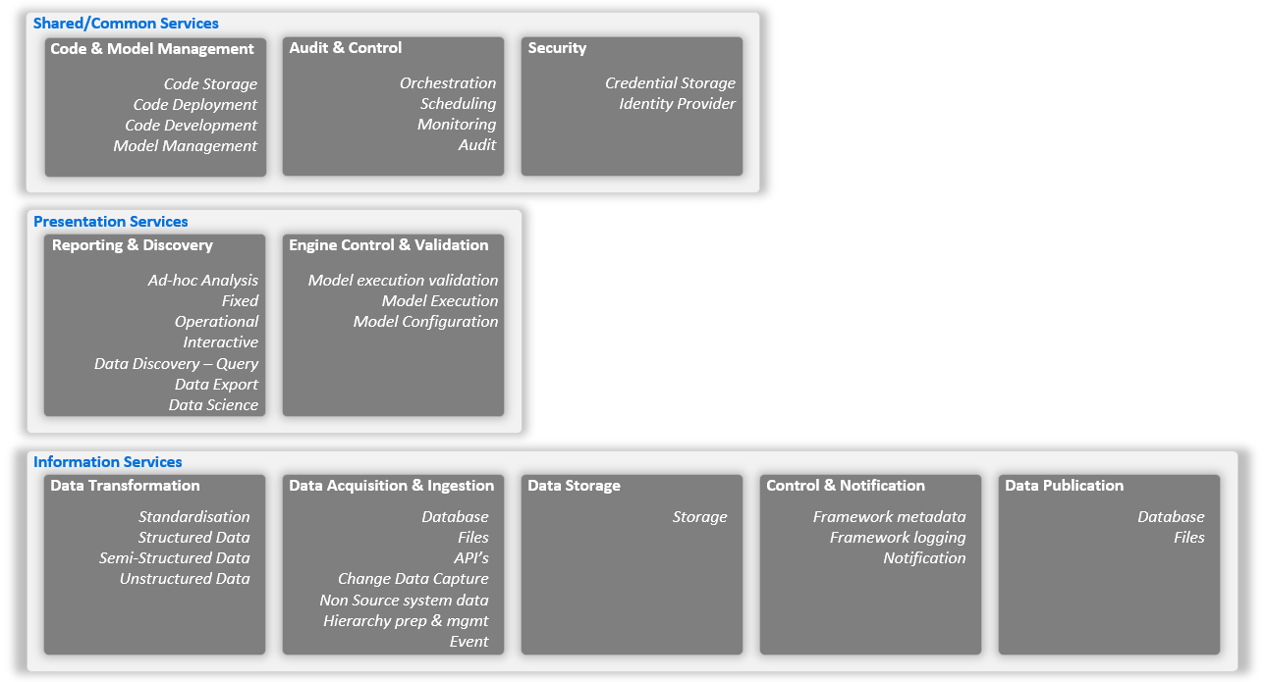
Figure 3.1 - Conceptual - Logical components
The following table provides an index to the logical application components, along with their domains and conceptual service.
LAC ID | Logical Application Component Domain | Logical Application Component (LAC) | Logical Application Component (LAC) Description
Shared/Common Services
LAC-1 | Code Management | Code Storage | Code stored centrally and managed through DevOps processes. Secure code storage with traceability of changes and approval gates for control of promotion of code through branches
LAC-2 | Code Management | Code Deployment | Code deployed from code storage to technology components within the platform. This should be performed through a gated (approval) release process with clear traceability of what code has been released to which environment and when.
LAC-3 | Code Management | Code Development | Development of code is necessary for the overall data platform to be able to meets the requirements. This code will need to be developed in appropriate tools for the technologies chosen for implementation
LAC-4 | Code Management | Model Management | Creation and management of Conceptual, Logical and Physical data models used throughout the data platform
LAC-5 | Audit & Control | Orchestration | Orchestration of tasks across the platform to execute such items as transformation services, data ingestion services, notification services.
LAC-6 | Audit & Control | Scheduling | The orchestrator will require a mechanism to initiate it. As there may be multiple pipelines, the orchestrator will be able to pipelines as set times, frequency and concurrency.
LAC-7 | Audit & Control | Monitoring | Monitoring of application components through collection, analysis of logs as well as understanding of the processes that have historically executed or are in progress on the data platform
LAC-8 | Audit & Control | Audit | Tasks or activities executed within the platform should log what is happening and what has happened. This will feed into the LAC-7 to ensure the platform can be monitored
LAC-9 | Security | Credential Storage | Credentials used by the platform, if not through service principals or managed identities should be stored in single secure store whilst meeting Securability requirements.  The credential store will be accessible by required platform technology components for the retrieval of details and mitigate storing of any credentials in code.
LAC-10 | Security | Identify Provider | Create, manage and maintains identities for architectural components and users across the platform. This will be used for authentication and authorization by the technology components to provide access.
Presentation Services
LAC-11 | Reporting & Discovery | Ad-hoc Analysis | Creation of a report or as "slice and dice" style analysis with filtering and interaction between presentation components where data is linked in the underlying semantic model
LAC-12 | Reporting & Discovery | Fixed | Fixed reports that can be parameter driven with scheduled delivery to recipients. These reports will be created with a designed structure and will have capabilities for formatting so that they can be exported or viewed in a good presentation format
LAC-13 | Reporting & Discovery | Operational | Operational reporting to support current business activity and support day to day operations of the business.  This component will be able to access data for operational reporting across the platform.
LAC-14 | Reporting & Discovery | Interactive | Pre-defined reports that enable users to interact with reporting elements through parameters/slicers, filtering, navigation, and drill down/through to understand and explain their information
LAC-15 | Reporting & Discovery | Data Discovery – Querying | Execution of SQL language queries on the data to explain or understand.
LAC-16 | Reporting & Discovery | Data Export | Export of data from the platform by end users through a fixed/interactive or ad-hoc report.  Export of data from the platform to other applications / files
LAC-17 | Reporting & Discovery | Data Science / Machine Learning | Capability to write and execute machine learning / data science models on the data within the platform.  Note that this does not cater for a full data science capability and that may be part of a future architecture.
LAC-18 | Engine Control & Validation | Model execution validation | Validation of the output of a model through a Fixed/interactive or Ad-hoc report
LAC-19 | Engine Control & Validation | Model Execution | This component will allow authorised users to perform an action that results in the execution of a model/engine within the platform.
Information Services
LAC-20 | Data Transformation | Standardisation | Data from various structures should have various standard operations performed, such as the addition of audit columns for traceability.
LAC-21 | Data Transformation | Structured data transformation | Structured data, for example typically from a database should be able to have operations applied to it to transform or combine with other data resulting in a structured data output and storage
LAC-22 | Data Transformation | Semi-Structured data transformation | Semi-structure data, for example JSON / XML will need to be query able and transformed or joined with other data resulting in a structured or semi-structured data output and storage
LAC-23 | Data Transformation | Unstructured data transformation | Unstructured data may need to be processed and there should be a capability to write transformations to be able to read and process the unstructured data and output to a structure or semi-structure output and stored.  The exact requirement and implementation for this may require custom code and will be further considered on a case-by-case basis.
LAC-24 | Data Acquisition & Ingestion | Database | Data from source databases will need to be retrieved and stored within the data platform. This component will be able to execute SQL language queries against various database systems to be able to extract data, transfer, and store.
LAC-25 | Data Acquisition & Ingestion | Files | Files may need to be identified, transferred, and stored within the data platform.
LAC-26 | Data Acquisition & Ingestion | API's | API’s may need to be called and the output retrieved and stored within the data platform.
LAC-27 | Data Acquisition & Ingestion | Change Data Capture | A change data capture component will monitor certain database systems for changes and send individual changes for later consumption within the data platform
LAC-28 | Data Acquisition & Ingestion | Non source system data entry | Users will be able to upload a small volume of data into a component that will be later extracted and stored in the data platform via a data ingestion component.
LAC-29 | Data Acquisition & Ingestion | Hierarchy preparation and management | Creation and management of hierarchies to be used in the data platform for transformation and / or reporting purposes.  Approval driven creation and update with notifications delivered to appropriate users.
LAC-30 | Data Acquisition & Ingestion | Events | An endpoint for event receipt, and storage of events for consumption by other platform components.  This component must also have the capability to persist events to storage as alternative means of collection by other components.
LAC-31 | Data Storage | Storage | A persistent, scalable, securable, and highly available storage service to be used by components across the platform.
LAC-32 | Control & Notification | Framework metadata services | Storage and retrieval of metadata to be used by components in the platform
LAC-33 | Control & Notification | Framework logging services | Components will be able to use the framework for logging progress events and errors to a central location
LAC-34 | Control & Notification | Notification Services | Capability for emails to be sent from the platform to recipients within Canopius. This may be further extended to other delivery services as required.
LAC-35 | Data Publication | Database | Data may need to be stored in other databases systems after certain transformations have taken place.  The component will be able to connect to the database and insert data into a specified location.  This functionally may change if an enterprise service bus is available
LAC-36 | Data Publication | Files | Data may need to be stored in files after certain transformations have taken place.  The component will be able to connect to the file system and insert data into a specified location.  This functionally may change if an enterprise service bus is available

Logical Application Component Characteristics
As this is a cloud platform, the working components selected should be generally securable, durable, highly available and accessible. Exceptions to this should be documented here.
Logical Application Component (LAC) | Logical Characteristic | Logical Characteristic Value

Logical Application Component Interactions
<<Application Architecture Logical-Level Artifact Contracts: This section may provide (in table format) descriptions of the contracts (i.e., interactions/relationships) between the logical application components in scope for the baseline application architecture.>>
LAC Contract ID | LAC 1 | LAC 2 | LAC Contract Description
LAC-C1 | * | Identify Provider | Components will use Identify Provider for authentication and authorisation
LAC-C2 | Code Deployment | Orchestration | Code deployment of Orchestration components
LAC-C3 | Code Deployment | Ad-hoc Analysis | Code deployment of Ad-hoc Analysis components
LAC-C4 | Code Deployment | Fixed | Code deployment of Fixed components
LAC-C5 | Code Deployment | Operational | Code deployment of Operational components
LAC-C6 | Code Deployment | Interactive | Code deployment of Interactive components
LAC-C7 | Code Deployment | Standardisation | Code deployment of Standardisation components
LAC-C8 | Code Deployment | Structured data transformation | Code deployment of Structured data transformation components
LAC-C9 | Code Deployment | Semi-Structured data transformation | Code deployment of Semi-Structured data transformation components
LAC-C10 | Code Deployment | Unstructured data transformation | Code deployment of Unstructured data transformation components
LAC-C11 | Code Deployment | Framework metadata services | Code deployment of Framework metadata services components
LAC-C12 | Code Deployment | Framework logging services | Code deployment of Framework logging services components
LAC-C13 | Code Development | Code Management | Code developed in the platform to be passed, stored and maintained.
LAC-C14 | Model Management | Code Management | Models developed for platform to be passed, stored and maintained.
LAC-C15 | Orchestration | Database | Orchestration will connect to databases, extract and store data
LAC-C16 | Orchestration | Files | Orchestration will connect to files and transfer to data platform storage
LAC-C17 | Orchestration | Non source system data entry | Orchestration will connect to non source system data entry supplier, extract and store data
LAC-C18 | Orchestration | Hierarchy preparation and management | Orchestration will connect to hierarchy preparation and management supplier, extract and store data
LAC-C19 | Orchestration | Credential Storage | Orchestration will connect to credential storage to retrieve credentials, connection strings or other items that are securely stored to connect to other components
LAC-C20 | Orchestration | Framework metadata services | Orchestration will connect to Framework metadata services to retrieve metadata to drive tasks to be executed
LAC-C21 | Orchestration | Framework logging services | Orchestration will connect to Framework logging services to store any progress or errors that are generated or captured during orchestration or data acquisition and ingestion
LAC-C22 | Orchestration | Standardisation | Orchestration will connect to Standardisation to execute relevant tasks
LAC-C23 | Orchestration | Structured data transformation | Orchestration will connect to Structured data transformation to execute relevant tasks
LAC-C24 | Orchestration | Semi-Structured data transformation | Orchestration will connect to Semi-Structured data transformation to execute relevant tasks
LAC-C25 | Orchestration | Unstructured data transformation | Orchestration will connect to Unstructured data transformation to execute relevant tasks
LAC-C26 | Orchestration | Storage | Orchestration will connect to Storage to store data retrieve from sources during acquisition and ingestion
LAC-C27 | Orchestration | Database | Orchestration will connect to Database to store data that needs to be published
LAC-C28 | Orchestration | Files | Orchestration will connect to Files to store files that needs to be published
LAC-C29 | Orchestration | Notification services | Orchestration will connect to Notification services to send data platform notifications to end users
LAC-C30 | Ad-hoc Analysis | Structured data transformation | Ad-hoc Analysis will connect to Structured data transformation to retrieve data for reporting
LAC-C31 | Fixed | Structured data transformation | Fixed will connect to Structured data transformation to retrieve data for reporting
LAC-C32 | Operational | Structured data transformation | Operational will connect to Structured data transformation to retrieve data for reporting
LAC-C33 | Interactive | Structured data transformation | Interactive will connect to Structured data transformation to retrieve data for reporting
LAC-C34 | Interactive | Framework metadata services | Interactive will connect to Framework metadata services to retrieve data used for data platform reporting
LAC-C35 | Interactive | Framework logging services | Interactive will connect to Framework logging services to retrieve data used for data platform reporting
LAC-C36 | Data Discovery - Querying | Structured data transformation | Data Discovery - Querying will use Structured data transformation for SQL language querying
LAC-C37 | Data Discovery - Querying | Semi-Structured data transformation | Data Discovery - Querying will use Semi-Structured data transformation for SQL language/python/pyspark querying
LAC-C38 | Data Discovery - Querying | Framework metadata services | Data Discovery - Querying will use Framework metadata services for SQL language querying to understand data platform metadata
LAC-C39 | Data Discovery - Querying | Framework logging services | Data Discovery - Querying will use Framework logging services for SQL language querying to understand data platform activity and errors
LAC-C40 | Data Export | Fixed | Data Export will use Fixed reporting to retrieve data to be exported
LAC-C41 | Data Export | Interactive | Data Export will use Interactive reporting to retrieve data to be exported
LAC-C41 | Data Science / Machine Learning | Structured data transformation | Data Science / Machine Learning will use Structured data transformation to perform analysis or model execution activities
LAC-C42 | Data Science / Machine Learning | Semi-Structured data transformation | Data Science / Machine Learning will use Semi-Structured data transformation to perform analysis or model execution activities
LAC-C42 | Data Science / Machine Learning | Unstructured data transformation | Data Science / Machine Learning will use Unstructured data transformation to perform analysis or model execution activities
LAC-C43 | Model execution validation | Interactive | Model execution validation will use Interactive to validate the execution results of an engine execution
LAC-C44 | Model Execution | Orchestration | Model Execution will use Orchestration to execute an engine within the data platform
LAC-C45 | Change Data Capture | Storage | Change Data Capture will use Storage to store the output of changes from source system databases. This will pass data through an intermediate message storage layer before persisting to storage
LAC-C46 | Semi-Structured data transformation | API's | Semi-Structured data transformation will access API's for the acquisition of data

Physical System Architecture
The target architecture is repeated in this section for ease of navigation, along with respective descriptions.
The following diagram represents a technology view of the solution architecture and illustrates the various interactions that can happen between components. It is designed to be flexible in its usage as the components are capable of carrying out multiple functions in some cases, but each will have primary purpose and usage.
-
Figure 3.2 - Physical Architecture

The above diagram represents the major technology components that will comprise of the target solution architecture. The solution is to manage the ingestion, processing and preparation of data from various source systems across the Canopius estate. It brings together the data to be used for reporting, but also to act as a processor for the delivery or availability of data to a limited number of other systems. The solution is capable of a variety or reporting capabilities ranging from fully interactive reports, through to query data discovery and data science.
It is designed to be built from components that are relevant in the market, commonly used and offer a level of scalability to meet Canopius’ foreseeable data requirements.
These components are split into another of areas such as:
- Platform services – These will be used or will make use of the other platform components to provide such attributes such as security, monitoring and dev ops.
- Integration services – Used for the access to source data for the data platform
- Integration & orchestration services – Provides orchestration of activity within the data platform, which will commonly be for the purposes of the extraction, transformation and loading of data, but also the enable orchestration of other process on the data platform that may be initiated by end users. Additionally, components here will be capable of extracting data from source systems / files.
- Platform metadata, logging, and auditing services – Any metadata that is used by other components in the architecture will be sourced from here and it will provide a common place for components to log as required and will also serve as a common place to understand what is happening across the architecture as jobs as in progress and what has happened for completed jobs.
- Transformation & Storage services – These components are really the core of the data platform and provide the capability to store, transform and query data.
- User services – These provide various access mechanism for management of data, reporting and process control.

The following diagram gives a view of some components together with a view of the high-level data architecture.
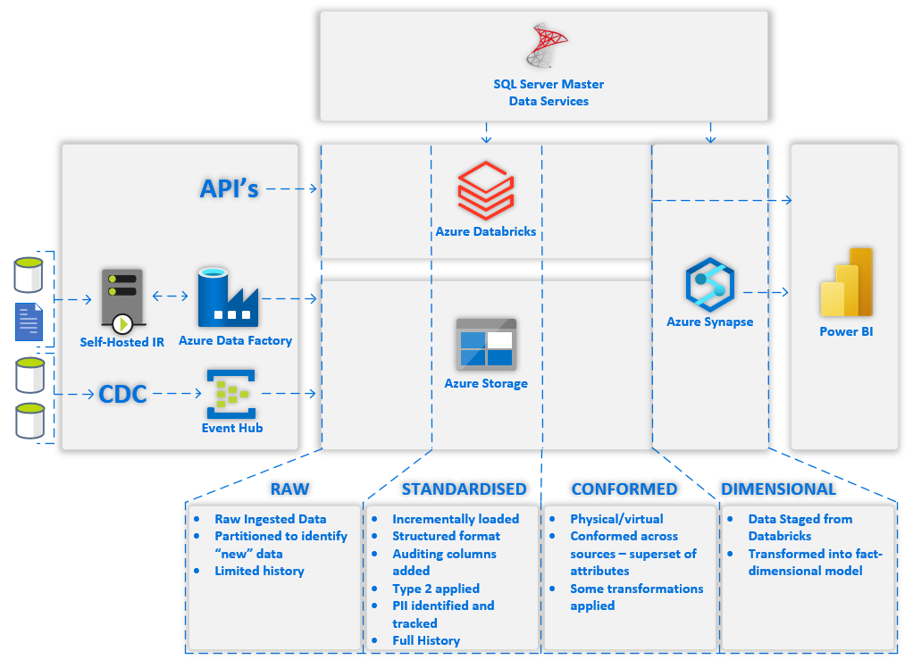
Figure 3.3 - Architecture high level data flow
The above diagram represents the majority use case of data flowing through the platform. To explain this, we will break down into several areas, describing their purpose and what they do.
Data Sourcing
- API’s – These are any API’s that need to be accessed by the platform to retrieve data into structured/semi-structured format. For this purpose, Azure Databricks will be used to source this as it is well positioned to access API’s and process the results in the variety of libraries available to python and PySpark capabilities.
- Azure Data Factory will make use of it’s integration runtime to access on-premises data sources such as databases and file stores. It has capability to get data from a variety of databases and pull that data into the Azure Cloud Platform and store in Azure Storage. The same applies for any files retrieved.
- A Change Data Capture (CDC) tool will be used to monitor database logs, identify transactions within those logs and send the records in the form of inserts, updates, deletes, and full tables refreshes where necessary to the cloud platform. These messages will be received into Azure Event Hub, which will then periodically store the messages to Azure Storage for further processing.

Data Processing & Storage
- Azure Databricks runs on the Apache Spark platform and has extensive capabilities of processing data using python, libraries (with boxed functionality) and PySpark. With these languages it is possible to perform extensive manipulation of data to move from an unstructured / semi-structured format to a structured one. This processing will take place through code in notebooks where these notebooks will be generic metadata driven and instantiated notebooks with transformations fully coded. An added advantage of Databricks is making use of its Delta format tables, which offer ACID transactions. This allows us to treat data in a very similar way to relational database tables, and through spark SQL language make these tables familiar to query.
- Azure Storage will be used for storage of data across the platform. It will be used to store data retrieved from API’s, from Azure data factory, from Event Hub, and will be the primary storage area for any data processed within databricks. Other technologies such as Synapse also use Azure Storage, but this is abstracted within synapse. Each of the “zones” above will be in a separate Azure Storage account that will be mounted to databricks so that it can access the files as required.
- Synapse has a “dedicated pool” that is a cluster based MPP relational database. It is designed for processing large volumes of data with efficiency and is aimed at data warehouse data models, and this is where the dimensional model will be housed.

Data Structure
- Raw is used for the ingest data into the platform and will also be used as the source for identification of changes.
- Standardised holds the full data history for each table from source as type 2 changes. It will also be the start of tracking PII. This data will be fully processed through azure databricks and stored in Azure Storage.
- Conformed will store the conformed modelled data across data source with required transformations and will allow for physical (tables) or virtual (view) storage. This data will be fully processed through azure databricks and stored in Azure Storage.
- Dimensional will be processed and held within Synapse dedicated pool and will be in the form of dimension and fact star schema structure. This will be the optimal structure for end user reporting. Transformations in stored procedures will take the data from the conformed shape to the fact dimension structure.

Presentation
- Power BI will be used for end user reporting through dashboards, reports, and paginated reports. It is anticipated the model within Power BI will hold all the data required for interactive and self-service reporting.

Orchestration & Scheduling
- Azure Data Factory will not only be used for ingesting and store data from databases (that are not available for CDC) and files, but also for the orchestration and scheduling of tasks across the platform. It will use metadata from the platforms Azure SQL Database to execute tasks in parallel and to achieve loading through the platform.
The following table breakdown the above diagram for each component specifying its purpose, type and logical component it may partially or wholly address:
Object Icon | Physical Component | Logical Component  (Domain – Component) | Purpose | Type
 | Azure Active Directory | Security - Identity Provider [LAC-10] | Handles user account authorisation and authentication from all components.  Groups of users will also be created here to help with consolidation of security so that when components make use of RBAC for management of resources or within the components for access and any security implementation that takes place within the components. | PaaS
 | Azure Monitor | Audit & Control – Monitoring [LAC-7] | Provides a centralized repository for the collection of metrics and logs of Azure components.  It will be used as an overview for understanding the health, performance, and utilisation of components | PaaS
 | Azure Key Vault | Security – Credential Storage [LAC-9] | Any items such as account names, passwords and connection strings that need to be stored will be stored here.  Components will retrieve these details to be able to make connections and authenticate with other necessary components. | PaaS
 | Azure DevOps | Code & Model Management – Code Storage [LAC-1] | Repos and branches will be used to hold all solution code.  There will be approval processes in place for the merging of branches through pull requests.  There will be full traceability across any change that is made to the code or when merged into other branches.  Details on branching, merging and approval will be documented separately. | SaaS
 | Azure DevOps | Code & Model Management –Code Deployment [LAC-2] | Deployment of code into components across environments will be through build and release pipelines.  This will make use of configuration values for each environment.  There will be full traceability with any code that is released from DevOps into environments which can be traced back through to originating branch and any changes and all changes made to the code during development. | SaaS
 | Power BI | Reporting & Discovery – Interactive [LAC-14] | Reports that are built utilising the semantic model can be deployed to controlled workspace in Power BI tenant and shared to end user groups via an app.  These reports can be designed to be attractive, functional and can have advanced interactions between components in the report  More detail on the governance practice for Power BI reporting | SaaS
 | Power BI | Reporting & Discovery – Ad-hoc analysis [LAC-11] | Reports utilising the semantic model can be used for end users performing slice and dice style analysis. | SaaS
 | Power BI | Reporting & Discovery – Fixed [LAC-12] | Paginated reports are the Power BI equivalent of SQL Server reporting services reports.  These reports offer a more “fixed” and structured view of data. It is possible to parameterise these reports so that the end user can select value and view the report in that context | SaaS
 | Power BI | Reporting & Discovery – Operational [LAC-13] | Dashboards, Reports and Paginated reports can all be used to view data that can be retrieved from across the data platform.  The combination of these reports provide a high level entry point in the dashboards that can lead into reports and then to enclosed or separate paginated reports. | SaaS
 | Power BI | Reporting & Discovery – Data Export [LAC-16] | Paginated reports provide a simple mechanism for accessing data across the data platform and a reliable way to export the data to common formats such as Excel, Word, PowerPoint, XML, CSV, PDF, Accessible PDF and Web Archive.  Reports offer two levels of export, where it is possible to export a visualisations data to Excel/CSV at either the data in the visual or the underlying data. These exports are capped at 150,00 and 30,000 rows respectively.  It is also possible to export an entire report, including all pages to a PowerPoint. This will produce a static version of the report. | SaaS
 | Power BI | Engine control & Validation – Model Execution Validation [LAC-18] | Dashboards and Reports can be used to give a view of engine execution output. This will allow finance & actuarial to view the result of processing. From this output they would be able to decide to approve.  Further requirements gathering and design with F&A may result in multiple tools being presented or linked through Power BI so that a Power BI report could be the one place they go to conduct an engine configuration and process. | SaaS
 | Power BI | Audit & Control – Monitoring [LAC-7] | Dashboards and Reports can source data from the Azure SQL database (metadata and logging) to give analysis of what has happened and what is happening. | SaaS
 | Azure Databricks | Data Transformation – Structured data transformation [LAC-21] | By making usage of PySpark dataframes and ACID Delta tables, data can be read in a structured format, transformed using many common SQL type transformation, but also with the additional capability of python expressions that can be more capable that standard SQL code.  For data retrieved from structured sources databricks will be used to read that data from Azure storage and perform initial standardization of the data and store the output into delta tables. | PaaS
 | Azure Databricks | Data Transformation – Semi-Structured data transformation [LAC-22] | Through a combination of python manipulation and its understanding of semi-structured formats such as JSON and XML it is possible to query and transform these semi-structured formats.  It is also possible to store data in a struct type, which adds possibility of nesting multiple levels of data. This is in appearance similar to XML where there can be multiple levels and each level can have multiple items. This can be used, where necessary to change a semi-structured data item into a structured data item, but maintaining the hierarchical nature of the data. | PaaS
 | Azure Databricks | Data Transformation – Unstructured data transformation [LAC-23] | PySpark can make use of multiple python libraries for processing of unstructured data, which may be text, image, sound, video or other formats such as but not limited to PDF.  This can be used for the processing of the unstructured data to either gain insights, or with the purpose of transforming it to a semi-structured or structured output. | PaaS
 | Azure Databricks | Data Acquisition & Ingestion – API’s [LAC-26] | Typically, data retrieval from API’s is through the REST protocol. This is fully supported within databricks through python functionality.  After retrieving this data, it can then be converted to a semi-structured or structured format for further transformation if required and stored.  If the API is hosted externally to the Canopius network, then there may need to be ports opened or exceptions to allow that connection to be established and data to transfer. | PaaS
 | Azure Databricks | Reporting & Discovery – Data discovery [LAC-15] | As databricks supports Spark SQL, which is a module for structure data processing, it is possible for Spark SQL to execute SQL queries over data tables registered as part of its HIVE repository.  Additionally, PySpark dataframes can be created and have transformations applied and then be referenced by SQL Language, making it a highly flexible platform for analysing data in a familiar language to most developers.  Access controls can be in place to provide table, row-level and column-level security.  Some development efforts may be required to enable this security once the requirement is known | PaaS
 | Azure Databricks | Reporting & Discovery – Data Science / Machine Learning [LAC-17] | Databricks has extensive data science capabilities and was founded as a data science platform.  Through its PySpark language, usage of python libraries, integration with model management tools it offers extensive data science and machine learning model processing capabilities.  This is currently not fully architected as the requirement has not been explored. This can take place once the data platform implementation has taken place or is in progress. | PaaS
 | Azure Databricks | Code & Model Management - Code Development [LAC-3] | The Azure Databricks has an online integrated development environment. This can be used for the authoring, testing and debugging of any databricks notebooks.  There is integrated source control connections with git based repositories, including Azure DevOps. | PaaS
 | SQL Server Master Data Services | Data Acquisition & Ingestion – Non source system data entry [LAC-28] | Data that is either generated by end users, sourced from locations that it is not possible or practical for the data platform to access will be entered here.  This data will be versioned, approved and can be validated.  Note that MDS is currently used in this way and has processes outside of the tool that fit with Canopius | IaaS
 | SQL Server Master Data Services | Data Acquisition & Ingestion – Hierarchy preparation & Management [LAC-29] | Hierarchies that need to be created that are not part of source system data can be created and managed for change. It will be possible to identify the change and have approvals in place for traceability.  Note that MDS is currently used in this way and has processes outside of the tool that fit with Canopius | IaaS
 | Power Automate | Engine control & Validation – Model execution [LAC-19] | This can provide a user accessible function for calling an Azure Data Factory pipeline for the orchestration of an engine execution.  This will provide a securable mechanism that is simple enough for an end user to trigger, especially with it’s Microsoft Teams integrations  This may be extended to have Power Apps for a user interface that can be embedded into Power BI so that there is a single place for the model execution and validation.  This will be further designed once requirements from Finance and Actuarial are fully understood and discussed. | SaaS
 | Azure Data Factory | Audit & Control – Orchestration [LAC-5] | Orchestration of the tasks that are required to execute within a batch processes. It will be driven by metadata to initiate a batch, will identify the stages that are to be executed in the batch, and for each stage the tasks that need to be run.  This process will be documented as part of data architecture.  In addition to orchestration of framework batches, it can also be used for orchestration of other tasks to be carried out on the data platform as required. | PaaS
 | Azure Data Factory | Audit & Control – Scheduling [LAC-6] | The built-in scheduling has capability to control the initiation of pipeline(s) at a time, frequency and concurrency.  A schedule may also supply parameters so that a pipeline execution may operated differently based on the parameter that is supplied for a schedule. | PaaS
 | Azure Data Factory | Data Acquisition & Ingestion – Databases [LAC-24] | The foundation of ADF was to copy data from one place to another, and this can be used to extract data from a variety of database and load to a variety of sources with good efficiency and speed.  This will be used to get data from on-premises or the azure cloud databases and bring them into the data platform as required. | PaaS
 | Azure Data Factory | Data Acquisition & Ingestion – Files [LAC-25] | File can also be identified and copied from one location to a variety of targets.  This will be used to gather files from on-premises or the azure cloud and bring them into the data platform as required. | PaaS
 | Azure Data Factory | Data Publication – Database [LAC-35] | Any data that requires pushing/publishing to another Canopius database can be delivered through ADF extracting the data from the data platform as part of a task and loading that into the target database | PaaS
 | Azure Data Factory | Data Publication – Files [LAC-36] | Any data that requires pushing/publishing to another Canopius database can be delivered through ADF extracting the data from the data platform as part of a task and loading that into the target file location. | PaaS
 | Azure Data Factory | Code & Model Management - Code Development [LAC-3] | Azure Data Factory has a built-in tool in called Azure Data Factory Studio. This can be used for the authoring, testing and debugging of any ADF pipelines.  There is integrated source control connections with git based repositories, including Azure DevOps. | PaaS
 | Azure Data Factory Self-Hosted Integration Runtime | Data Acquisition & Ingestion – Databases, Files [LAC-24], [LAC-25] | This will serve as the on-premises component that Azure Data Factory will use to access on-premises databases and files.  This will be hosted on a windows server | Virtual / Physical Machine
 | Azure Synapse (Dedicated Pool) | Data Transformation – Structured data transformation [LAC-20] | Synapse dedicated pool will serve as the data warehouse for the platform, housing the dimension model of facts and dimensions.  It is optimised for data warehouse workloads and capable for scaling from medium to large workloads. It achieves this by internally separating compute from storage where through configuration the number of compute nodes can be scaled and each of these nodes can use distributions of data in storage.  As synapse dedicated pool is a relational database it makes use of SQL tables, views, functions, and stored procedures, however the tables can have defined distributions to be replicated (typically used for dimensions), hash or round-robin distributed.  These known distributions allow for extremely fast querying and joining of tables. | PaaS
 | Azure Synapse (Dedicated Pool) | Reporting & Discovery – Data discovery [LAC-15] | The highly scalable nature of the platform can allow a limited number of users to access and query the database.  Access controls at an object, column and row-level can be implemented to control who can access what in the platform. | PaaS
 | Azure Storage | Data Storage – Storage [LAC-31] | Used by Azure Databricks for the reading and storage of data. There will be multiple storage accounts to help mitigate input output operation tier limits. Where there will be one account per “zone”. Zones will be documented in the data architecture.  Synapse uses a storage account as its primary storage account for workspace data. There is no user interaction with this account once created.  Azure data factory will use a container within a “raw” storage account to store the data that it retrieves from sources, e.g. database / file sources. | PaaS
 | Azure SQL Database | Control & Notification - Framework metadata services [LAC-32] | As part of the framework described in data architecture, there is a large metadata component where data will need to be stored and retrieved in a structured format. An Azure SQL Database will be used for this purpose | PaaS
 | Azure SQL Database | Control & Notification - Framework logging services [LAC-33] | As part of the framework described in data architecture, any components that need to log progress or error will do so in the SQL Database. This will be a central place for application code logging progress or errors.  This will also enable understanding of what is happening across the tasks in the platform at any point in time, and also what happened during a batch execution | PaaS
 | Azure Event Hubs | Data Acquisition & Ingestion – Events [LAC-30] | As part of the target architecture a CDC tool (TBC) would be used to send messages (database table transactions) to an end point, such as Event Hub.  Event hub can then be used for a number of options such as using data capture to persist the data to Azure Storage after a period of time or if a certain “size” of messages are available.  It can also be used to activate other components, for example Azure Functions or can be used as a streaming source by various technologies.  This opens up current and future data access and reporting options. | PaaS
 | Visual Studio | Code & Model Management - Code Development [LAC-3] | Visual Studio will be used as a project solution for developing and maintaining any Azure SQL Database and Azure Synapse code. | Desktop Software
 | erwin data modeller | Code & Model Management - Model Management [LAC-4] | Erwin will be used for the development and maintenance of the conceptual, logical and physical models for both the data lake and the data warehouse.  As part of this, it will also house the additional metadata and mappings required for the framework. | Desktop Software
CDC | TBD | Data Acquisition & Ingestion – Events [LAC-27] | A TBD change data capture tool that monitors database transactions, identifies them and delivers them to Azure EventHub for further consumption.  The selection is currently in progress, and this document will be updated when more information is available. At the time of writing, IBM Data Replication, Qlik Replicate and HVR are being considered. | TBD
Table 2.1 - Hardware and Software Technologies

Security Architecture

Security Solution Overview
Security architecture is based on the “Least Privilege” principle. A least privilege enterprise model designed for architectural assurance is implemented in a comprehensive access control model. As a result, logical access controls are based on the principle of role-based access control (RBAC). User access is granted to the minimum resources required to perform their official job functions.
RBAC is assumed to be the security requirement model to be implemented at all levels of the enterprise from network access control at the device level, database access control at the data level, application-level access control, as well as user access.
The infrastructure components for this model at include Azure Active Directory. This will be used as previously identified, as the identify provider [LAC-10]. Any components in the platform that are designated to be user accessible will authenticate and authorise by using the identify provider.
Platform service components may use service principal or managed identity accounts to connect to other services, and these would be managed through Azure Active Directory. The specification of which will be through the Cloud Infrastructure document.
Data Security
At present, there is no specific requirement for security at a data level for row or column level security, however, this has been considered in selection of the technologies in the platform where data can be accessed and what their capabilities are. The technologies considered under this are Power BI, Azure Synapse – dedicated pool and Azure Databricks.
The following table represents initial options for each of these components.
Service | Option | Description | Uses Active Directory | Uses Active Directory Groups | Data Driven
Power BI | Row level security | Roles created in the model and people are assigned to the role in the published dataset, and publish in an app. Attributes can be filtered based on a value, for example these can be hardcoded to a syndicate name(s) or through an email address where it is possible to say this email address has access to these policies (performance consideration) | Yes | Yes | Yes
Power BI | Model Security | Only load data into a model that a particular set of users have access to, and publish through a Power BI app | Yes | Yes | No
Power BI | Column level security | Select permission granted to only the columns the user / group is allowed to see. This should generally be presented through a view so that the end user does not select the disallowed column. | Yes | Yes | No
Synapse | Row Level Security | Either directly against a table or by calculating a key on a table and having a user security table with the attributes and generated key. This is used in a function which is applied through security policy to an object (table / view) | Yes | Yes | Yes
Synapse | Views (row / column) | Create a view with appropriate filters/columns in place against the data and only provide access to the views to appropriate users/groups | Yes | Yes | Yes
Synapse | Tables (row / column) | Specifically write out tables with specific access to a user group | Yes | Yes | No
Synapse | Column level security | Select permission granted to only the columns the user / group is allowed to see. This should generally be presented through a view so that the end user does not select the disallowed column. | Yes | Yes | Partial
Databricks | Row Level Security - Views | Either directly against a table or by calculating a key on a table and having a user security table with the attributes and generated key. This is applied through a case statement in the where clause in the view which also checks to see if the user is a member and then returns appropriate item for the where clause | Yes | No | Yes
Databricks | Views (row / column) | Create a view with appropriate filters/columns in place against the data and only provide access to the views to appropriate users/groups | Yes | No | Yes
Databricks | Tables (row / column) | Specifically write out tables with specific access to a user group | Yes | No | Partial
Databricks | Column Level Security - Views | Managed in a very similar way to the row level security. The column when selected is through a case statement that checks if a user is part of a group and then will show the data or redact it. | Yes | No | No
Data Export Control
Although there is no requirement for the control of exporting data from the platform, as it is even a requirement to export data, the following has been identified as capabilities of Power BI and may be used for consideration in the future.
It is currently possible to restrict data exports from the power bi service for both reports and paginated reports at the tenant and report level for all or for certain user groups. Additional documentation on this can be found here https://powerbi.microsoft.com/en-us/blog/new-export-settings-are-available-in-the-power-bi-admin-portal/.

Security Architecture Goals and Constraints
Goals:
Security Architecture goals are to provide integrity, confidentiality, availability, non-repudiation, and privacy, transparently to the user, and seamlessly to all business conducted via the network.
Security architecture goals are to provide Integrity, confidentiality, availability.
- Integrity - Ensure that all data stored is reliable, accurate, and not subject to unwarranted changes
- Confidentiality – Ensures that data is accessed only by authorised users with the proper credentials.
- Availability - Ensures that data is readily, and safely accessible and available for ongoing business needs.
- Least Privilege – Ensures that any user, program, or process should have only the bare minimum privileges necessary to perform its function.
Constraints:
The only specified constraints of technology components with security are using Azure RBAC for component level access, components connect to each other through managed identity or service principal and that user and component access is authenticated and authorised through Azure Active Directory.
Note that the security architecture will also be documented as part of the Cloud Infrastructure document.

